LAB – 8

NAYAKANTI SAI MIHIRNATH - 210905368
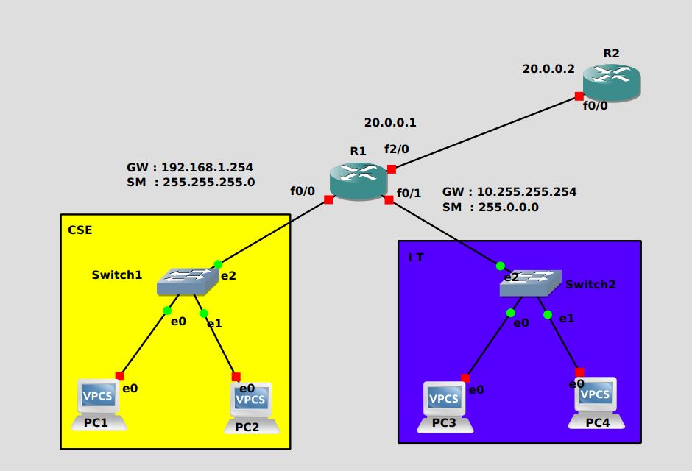

Configuring Routers : -

R1

conf t

int f0/0
ip address 192.168.1.254 255.255.255.0
ip helper-address 20.0.0.2
no shut
exit

int f0/1
ip address 10.255.255.254 255.0.0.0
ip helper-address 20.0.0.2
no shut
exit

int f2/0
ip address 20.0.0.1 255.0.0.0
no shut
exit

R2

conf t

int f0/0
ip address 20.0.0.2 255.0.0.0
no shut
exit

ip dhcp pool CSE
network 192.168.1.0 255.255.255.0
default-router 192.168.1.254
exit

ip dhcp pool IT
network 10.0.0.0 255.0.0.0
default-router 10.255.255.254
exit

